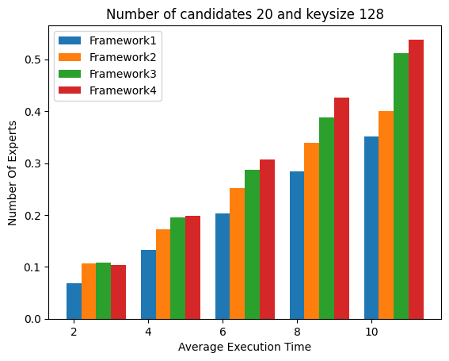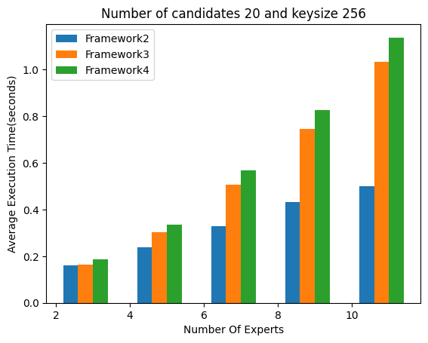

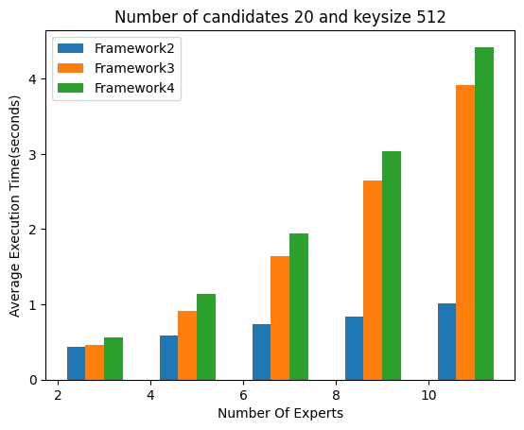

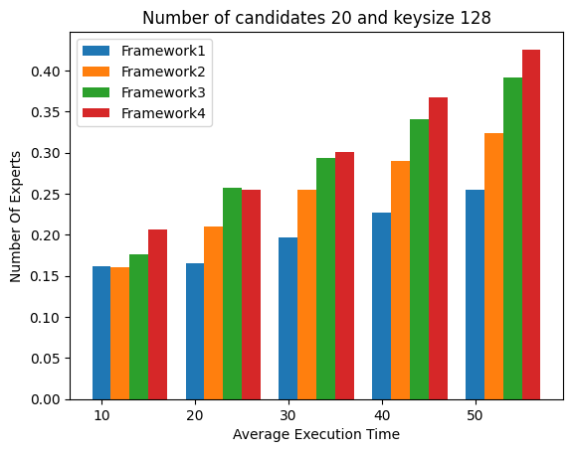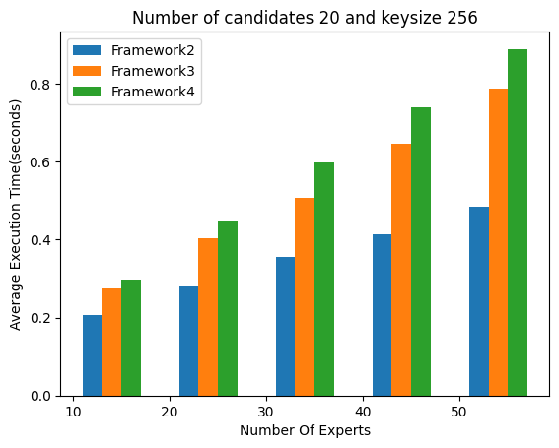

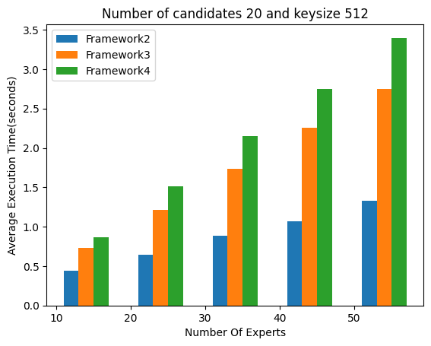

array([0.06843379, 0.13319737, 0.20307197, 0.2847123 , 0.35098764],

dtype=float32)

[array([0.10631906, 0.17243011, 0.25171918, 0.33977574, 0.4002084 ],

dtype=float32),

array([0.15987162, 0.23938051, 0.32986274, 0.43167755, 0.49948916],

dtype=float32),

array([0.4376447 , 0.5927597 , 0.74291015, 0.8388526 , 1.015362 ],

dtype=float32)]

[array([0.10832474, 0.19533773, 0.2863506 , 0.38795227, 0.51155794],

dtype=float32),

array([0.16429195, 0.3019616 , 0.50540304, 0.74671656, 1.0339577 ],

dtype=float32),

array([0.45608073, 0.9171217 , 1.6353066 , 2.6402194 , 3.911733 ],

dtype=float32)]

[array([0.1037539 , 0.19912069, 0.30756855, 0.42553675, 0.53824055],

dtype=float32),

array([0.18688777, 0.33698004, 0.5697279 , 0.82561517, 1.1382107 ],

dtype=float32),

array([0.55944234, 1.1409328 , 1.9436456 , 3.0361922 , 4.419816 ],

dtype=float32)]

Here is the second setting of data

array([0.16205233, 0.1652601 , 0.19638124, 0.22701246, 0.25425407],

dtype=float32)

[array([0.16021727, 0.21012537, 0.25500366, 0.28953773, 0.32375282],

dtype=float32),

array([0.20542125, 0.28252786, 0.35645914, 0.41493967, 0.48350435],

dtype=float32),

array([0.443448 , 0.64522135, 0.88082796, 1.0732341 , 1.3341835 ],

dtype=float32)]

[array([0.17636165, 0.25740606, 0.2932879 , 0.34023923, 0.39190933],

dtype=float32),

array([0.27665347, 0.4047608 , 0.5068999 , 0.64569736, 0.78831536],

dtype=float32),

array([0.72633725, 1.2131103 , 1.7344682 , 2.253476 , 2.7483165 ],

dtype=float32)]

[array([0.20594274, 0.25528935, 0.3002323 , 0.36745644, 0.42551547],

dtype=float32),

array([0.29658115, 0.448291 , 0.59775406, 0.73987705, 0.88980967],

dtype=float32),

array([0.8631509, 1.5103332, 2.1488519, 2.750183 , 3.3985343],

dtype=float32)]